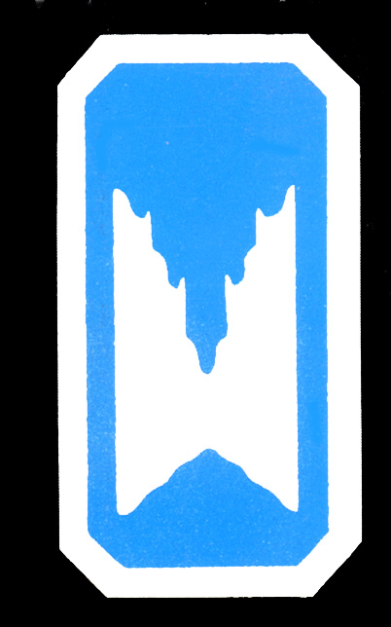


2001 Fall VAR

Hosted by the Richmond Area Speleological Society

You are most cordially invited to attend the 2001 Fall VAR hosted by the Richmond Area Speleological Society.

Dates: September 28 – 30, 2001 starting at noon on Friday.

Location: The RASS Field Station in Bath County, VA (see attached directions). The property consists of 26 acres of meadow and wooded hillside (camping space is plentiful). Since its acquisition, members of the RICHMOND AREA SPELEOLOGICAL SOCIETY have established vehicular paths, renovated the storage shed, converted the dwelling into a functional bunk house, erected four outhouses and built the bath house and pavilion.

Cost: A pre-registration fee of $18.00 per registrant ($23.00 at VAR / children age 5 and under are free) will cover the cost of the VAR Guidebook and the Saturday evening meal of our world renowned Brunswick Stew.

Please pre-register by filling out the form and returning it no later than September 8th, 2001. Registrations may be sent to:

2001 Fall VAR
c/o Rich Geisler
11501 Greenwood Rd
Glen Allen, VA 23059

We hope you take the opportunity to visit some of the fine caves of our area and come enjoy your stay with us at the 2001 Fall VAR.

For further information please see our website at:
http://www.caves.org/grotto/rass/

